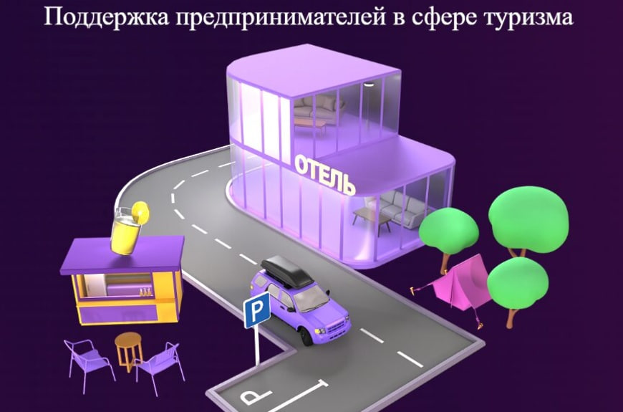

--[https://мсп.рф/services/tourism/promo/](https://xn--l1agf.xn--p1ai/services/tourism/promo/)  
<https://xn--l1agf.xn--p1ai/services/tourism/promo/>